ONLINE FOOD ORDERING & DELIVERY MANAGEMENT SYSTEM
Project Report
Prepared by: Murgan Swami M & Lokesh V
Project Guide: Vijaya
Institution: Anudip Foundation
Course: Advanced Java Programming

ABSTRACT
The Online Food Ordering & Delivery Management System is designed to simplify the process of ordering food online. This project provides users with access to restaurants, menu items, and an ordering interface, while maintaining secure data processing through Hibernate ORM and MySQL. The application follows a layered architecture with clear separation between UI, Service, DAO, and Model components.

INTRODUCTION
Online food ordering systems have become a crucial part of the modern lifestyle. With smartphones and the internet, customers prefer ordering food online and getting it delivered at their doorstep. This system provides seamless access to available restaurants, menu browsing, order placement, and viewing order history.

PROBLEM STATEMENT
Traditional food ordering involves long waiting times, communication issues, and limited choices. There is a need for a fast and interactive digital system that enables users to order food from different restaurants with secure transaction handling and real-time updates.

PROJECT OBJECTIVES
- Provide an easy and fast food ordering platform for users.
- Allow restaurants to manage and list menu items.
- Ensure secure data storage using Hibernate ORM.
- Implement authentication for registered users.
- Provide order history and reporting features.

SCOPE OF THE PROJECT
This project is limited to online ordering and basic sales reporting. It does not include payment gateway integration, restaurant onboarding automation, or delivery tracking.

MODULES OF SYSTEM
1. User Registration & Login Module
2. Restaurant and Menu Management Module
3. Food Ordering Module
4. Order History Module
5. Admin Reporting Module

SYSTEM ARCHITECTURE
The project follows a 5-layer architecture including UI Layer, Service Layer, DAO Layer, Hibernate Layer, and Database Layer ensuring modularity, separation of concerns, and scalability.
Architecture Layers:
- 1. Presentation/UI Layer (Console input/output)
- 2. Service Layer (Business logic)
- 3. DAO Layer (CRUD operations)
- 4. Hibernate Layer (ORM communication)
- 5. Database Layer (MySQL storage)
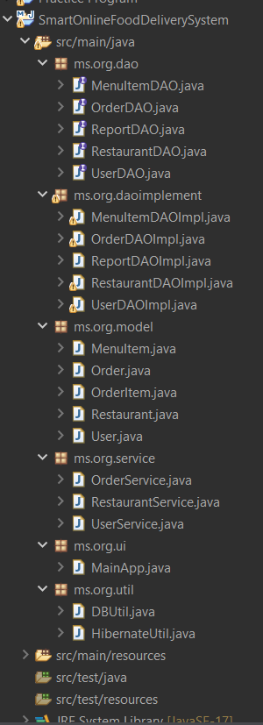
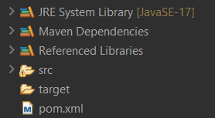

ER DIAGRAM

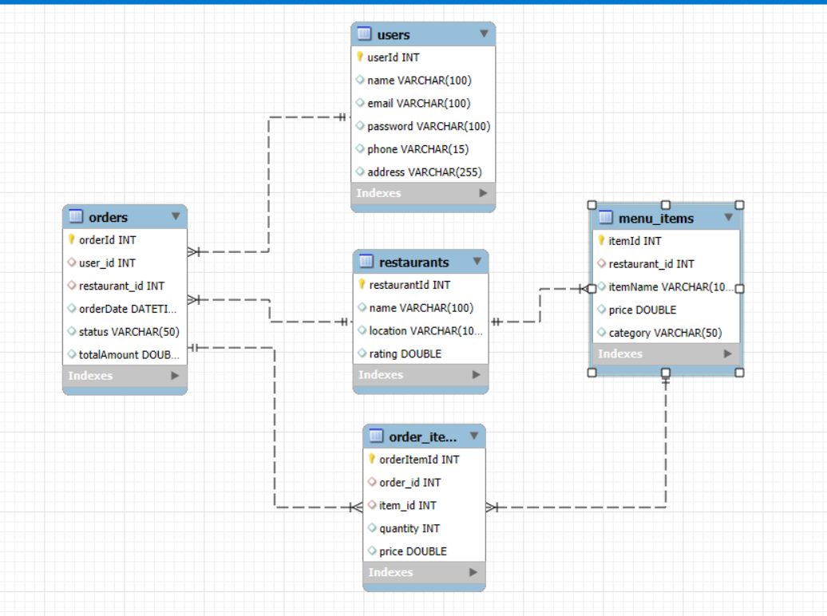

TECHNOLOGY USED
- Programming Language: Java
- IDE: Eclipse
- Database: MySQL
- ORM: Hibernate
- Build Tool: Maven
- JDBC: Used for Reporting Module

DATABASE DESIGN
The system consists of tables such as Users, Restaurants, MenuItems, Orders, and OrderItems. Each user can place multiple orders, and each order can contain multiple menu items.

TESTING
The system was tested using manual testing techniques including input validation, empty input testing, database validation, and exception handling.

FUTURE ENHANCEMENTS
- Add real-time order tracking.
- Integrate payment gateway.
- Include delivery agent module.
- Add offers and coupons system.
- Enable restaurant admin panel.

OUTPUT

- Login Page
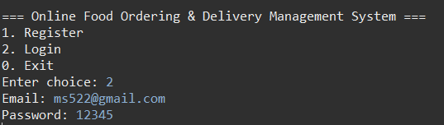
- Order Table
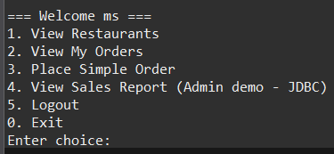
- View Restaurants
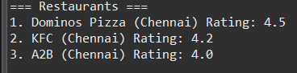
- View My Orders
- Place Simple Order
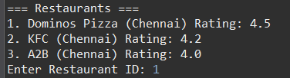
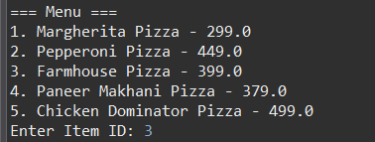
- View Sales Report (Admin demo – JDBC
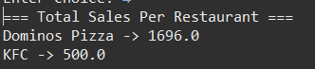

CONCLUSION
The Online Food Ordering & Delivery Management System provides a complete solution for customers to browse restaurants, view menu items, place orders, and track their order history. The system is secure, reliable, and scalable for future development.

--- END OF REPORT ---

